**Chapter No: 4 - System Analysis**

4.1 Analysis (SDLC)

4.2 Design

**USE CASE DIAGRAM**

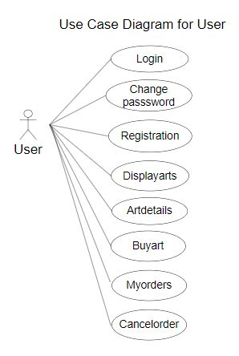

**CLASS DIAGRAM (OOP)**

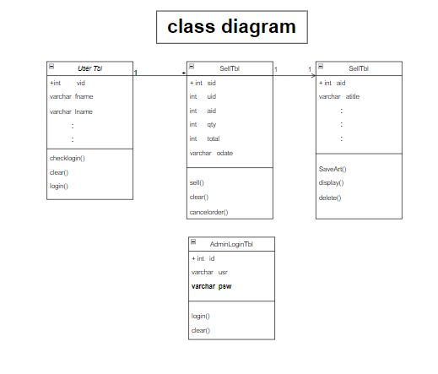

**E-R DIAGRAM**

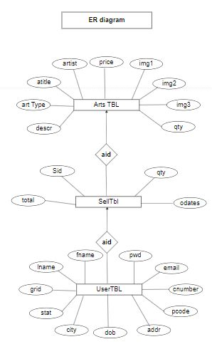

**DATA FLOW DIAGRAM (DFD)**

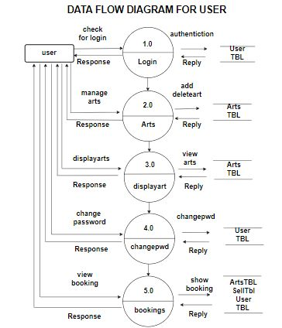

**DATA FLOW DIAGRAM (DFD)**

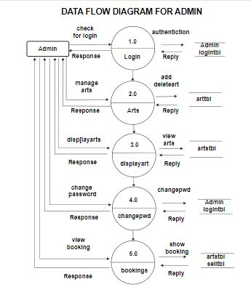

**ACTIVITY DIAGRAM FOR ADMIN**

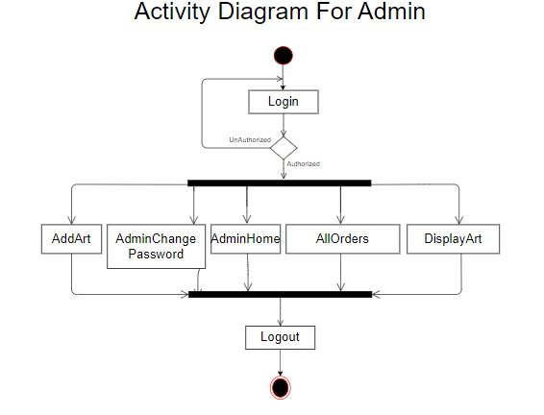

**ACTIVITY DIAGRAM FOR USER**

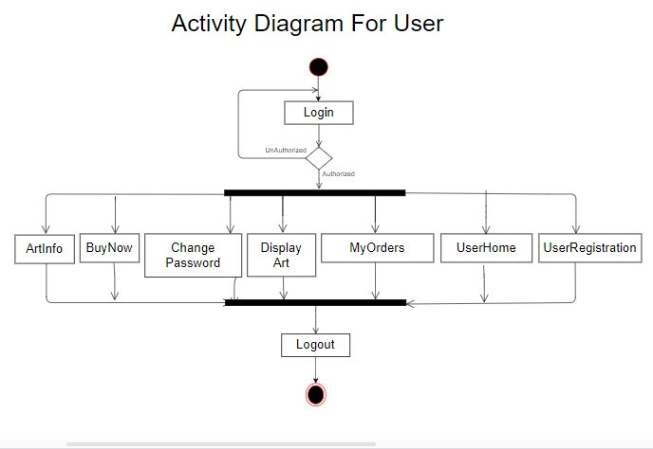

**DATA DICTIONARY**

## Tables :

## ArtsTBL

|  |  |  |
| --- | --- | --- |
| **Column Name** | **Data type** | **Constraint** |
| aId | int | P.K. |
| Arttype | Varchar(50) | - |
| Atitle | Varchar(MAX) | - |
| Artist | Varchar(50) | - |
| Img1 | Varchar(MAX) | - |
| Img2 | Varchar(MAX) | - |
| Img3 | Varchar(MAX) | - |
| Qty | int | - |
| Price | int | - |
| descr | Varchar(MAX) | - |

## SellTbl

|  |  |  |
| --- | --- | --- |
| **Column Name** | **Data type** | **Constraint** |
| Sid | int | - |
| Aid | Int | - |
| Uid | int | - |
| Qty | int | - |
| Total | int | - |
| odate | Varchar(50) | - |

|  |  |  |
| --- | --- | --- |
| **Column Name** | **Data type** | **Constraint** |
| id | int | p.k. |
| usr | Varchar(50) | - |
| psw | Varchar(50) | - |

## AdminLoginTBL

* **userTBL**

|  |  |  |
| --- | --- | --- |
| **Column Name** | **Data type** | **Constraint** |
| Id | int | P.K. |
| fname | Varchar(50) | - |
| lname | Varchar(50) | - |
| Gnd | Varchar(50) | - |
| stat | Varchar(50) | - |
| city | Varchar(50) | - |
| Bod | Varchar(50) | - |
| Addr | Varchar(50) | - |
| Pcode | Varchar(50) | - |
| Cnumber | Varchar(50) | - |
| Email | Varchar(50) | - |
| Pwd | Varchar(50) | - |